ActiStruct: ActiStruct: Active-Learning Inverse Design for DFT Structure Optimization
Supporting results and validation prepared for a JCTC submission
Quantum ESPRESSO oracle, Gaussian-process surrogate, lower-confidence-bound acquisition. 50-system benchmark. June 2026.

Abstract
Finding the lowest-energy geometry of a material with density functional theory usually means running many single-point calculations over a grid of trial structures, and most of that cost is far from the minimum. This document reports the results of ActiStruct, a workflow that replaces the grid with a small active-learning loop. The loop runs Quantum ESPRESSO for the energy, fits a Gaussian process to the points it has already computed, and uses that model to pick the next structure to evaluate. We tested it on 50 systems that cover metals, semiconductors, oxides, two-dimensional materials, small molecules, battery cathode models, surface adsorption models, and one intermetallic. Across the set the loop reached the same energy minimum as a full grid while running 311 calculations instead of 1174, which is about 73 percent fewer. Measured against the real wall-clock time of those calculations, this is 54.0 hours of compute instead of a projected 183.6 hours. For the 34 systems that have published reference structures, the recovered lattice constant or bond length is within 0.64 percent of the reference on average, and the worst case is 4.0 percent. Three systems were checked against a fully computed grid and matched the grid minimum to better than 1 meV per atom. An ablation on those three systems shows that the Gaussian process is what produces the saving: random and space-filling sampling need two to four times as many calculations to reach the same point. The two most demanding systems, LiCoO2 and Co on Cu(111), were run with an 80 Ry cutoff and tight convergence, and LiCoO2 with spin polarization, so the hardest cases use production-quality settings. The method is limited to searches over one or two structural variables and to cases where a single-point total energy is a sensible objective. For most systems the grid baseline is projected from the measured cost per call rather than run in full, and three systems were enumerated completely to support that projection.

Contents
Abstract 1
Contents 1
1 Introduction 1
2 Method 1
2.1 Problem definition 1
2.2 Active-learning loop 1
2.3 Gaussian-process model and acquisition 1
2.4 Quantum ESPRESSO oracle and caching 1
2.5 Benchmark design 1
2.6 Baselines and validation metrics 1
3 Results 1
3.1 Benchmark coverage and convergence 1
3.2 Efficiency against the grid baseline 1
3.3 Direct grid validation 1
3.4 Baseline and ablation comparison 1
3.5 Uncertainty behavior 1
3.6 Structural sanity check 1
3.6.1 Per-category summary 1
4 Discussion 1
4.1 What the workflow does 1
4.2 What it does not do 1
4.3 Limitations to state in the manuscript 1
4.4 Extensions 1
5 Conclusions 1
Data and Code Availability 1
Appendix A Quantum ESPRESSO settings by system 1
Appendix B Per-system efficiency 1
Appendix C Data integrity 1
C.1 Excluded and stale runs 1
C.2 Planned direct grid validations 1
C.3 System status 1
Appendix D Reference provenance 1
Selected references 1

1 Introduction
A common task in computational materials work is to optimize a small number of structural parameters, such as a lattice constant, a bond length, the thickness of a two-dimensional layer, or the height of an adsorbate above a surface. The standard way to do this is a grid scan. The structure is built at each point on a grid, the energy is computed with DFT, and the lowest point is taken as the answer. This is reliable but wasteful. The cost grows quickly when there is more than one parameter, and almost all of the calculations land in regions that are obviously not the minimum.
Surrogate-based optimization offers a cheaper route. A statistical model is trained on a few DFT points, and that model is used to decide where to compute next. This idea is well established in the Bayesian optimization literature and has been applied to atomistic problems before, for example in the BOSS package. The contribution here is not a new electronic-structure method and not a new acquisition function. It is a careful measurement of how much a simple, reproducible version of this loop saves in practice across a wide range of chemistries, using real Quantum ESPRESSO calculations as the oracle rather than a model potential.
The claim this document supports is narrow on purpose. Across a chemically diverse benchmark, ActiStruct reaches the same DFT energy minimum that a full grid would reach, while using about 73 percent fewer Quantum ESPRESSO calls, and the recovered structural parameters agree with published references to about 0.6 percent on the systems where a reference exists. The document is organized so that the strongest evidence, agreement with brute-force minima and the cost reduction, is separated from the weaker evidence, agreement with literature values, which depends on the choice of functional and is treated only as a sanity check.

2 Method

2.1 Problem definition
Each system is described by one or two continuous structural variables with fixed bounds. The objective is the Quantum ESPRESSO total energy, or total energy per atom, evaluated as a single self-consistent calculation at the trial geometry. The goal is to find the variable values that minimize this energy using as few calculations as possible. No geometry relaxation is performed inside a calculation, so the search is over the chosen variables only.

2.2 Active-learning loop
The loop starts by computing the energy at three or four seed geometries and fitting a Gaussian process to them. It then repeats four steps until a stopping rule is met.
- Score every candidate geometry with the lower confidence bound, defined as the predicted mean minus the predicted standard deviation. This favors points that are either low in predicted energy or poorly known.
- Minimize the lower confidence bound over the continuous bounds with differential evolution, and take the result as the next geometry. An earlier version searched a fixed grid of candidate points instead, which limited the proposal to grid positions.
- Run one Quantum ESPRESSO calculation at the proposed geometry and add the result to the training set.
- Refit the Gaussian process. Stop when the model uncertainty at the current best point falls below 0.03 eV per atom and the predicted improvement falls below 1 meV per atom.
When the loop stops, the trained model is minimized once more over the full range to report the predicted best geometry.
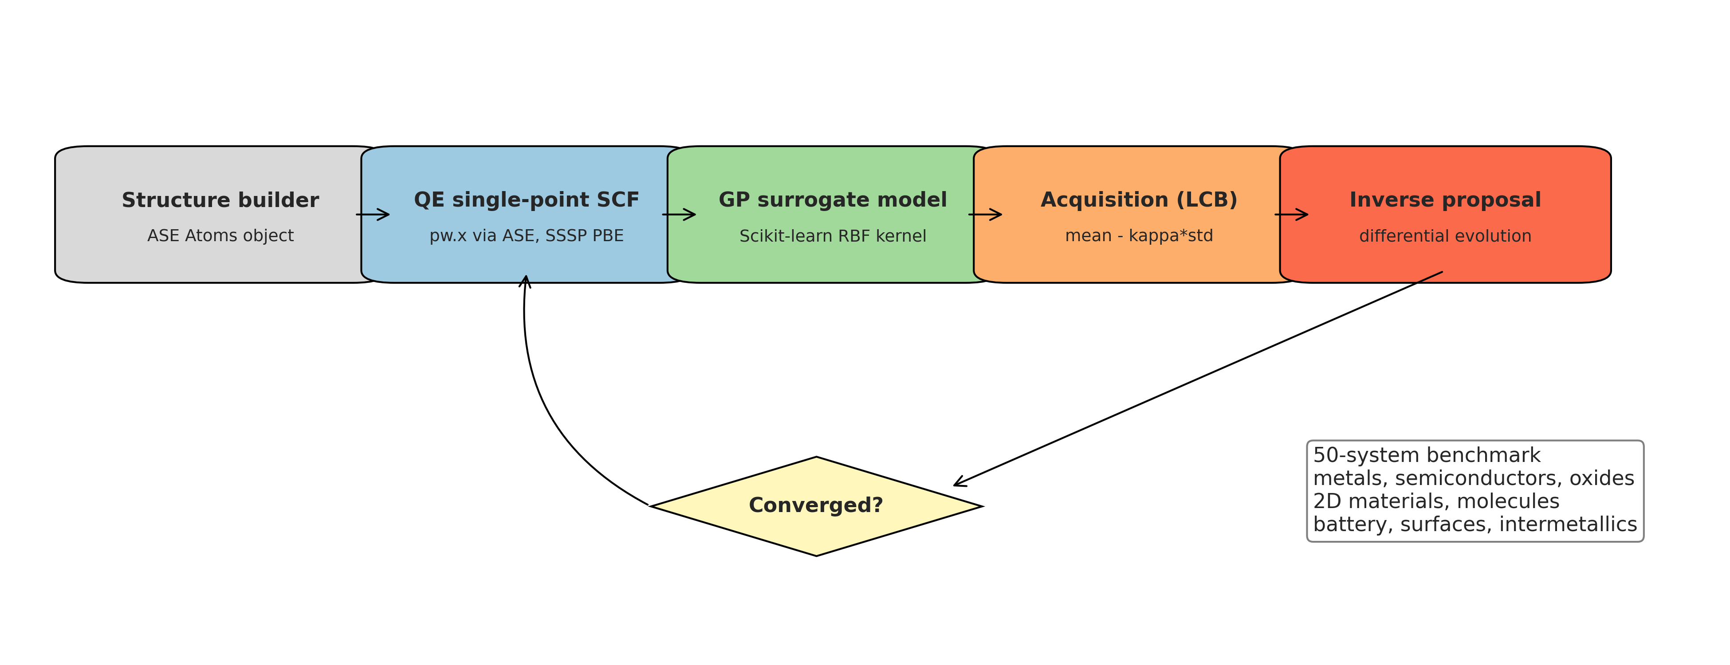
Figure 1. The ActiStruct loop. Structures are built with ASE, energies come from Quantum ESPRESSO, a Gaussian process is fit to the points seen so far, and the acquisition function chooses the next geometry until the stopping rule is met.

2.3 Gaussian-process model and acquisition
The surrogate is a Gaussian process with a radial basis function kernel and a small noise term, fit with input normalization. The acquisition is the lower confidence bound with a weight of one on the uncertainty term. These are standard choices. Section 3.4 reports an ablation that replaces this acquisition with simpler alternatives to show how much the surrogate and the uncertainty term each contribute.

2.4 Quantum ESPRESSO oracle and caching
All energies use the PBE functional with the SSSP 1.3.0 PBE efficiency pseudopotential library. The convergence threshold is 1e-8 Ry. Plane-wave cutoffs run from 40 to 80 Ry depending on the elements, with charge-density cutoffs scaled to match, and k-point meshes and smearing chosen per category. The oracle is Quantum ESPRESSO 7.4.1 pw.x, driven through ASE and run with mpirun on two MPI ranks. Every computed energy is cached by system and geometry, so repeated analysis never recomputes a point. Per-system settings are listed in Appendix A.

2.5 Benchmark design
The benchmark has 50 systems in nine groups. The groups were chosen to span bonding types and cost, from a few-atom molecule that runs in seconds to a transition-metal oxide that takes well over an hour per call. LiCoO2 was held out of an earlier version of this benchmark because its cached report had gone stale after a wrapper change. It has since been rerun cleanly with spin polarization and an 80 Ry cutoff, and it is now included, which brings the set to 50 with no stale entries. CO on Cu(111) was also rerun with the same higher cutoff and tight convergence and now optimizes both adsorption height and lateral shift. These two are the most carefully converged systems in the set. The full list and per-system status are in Appendix C.
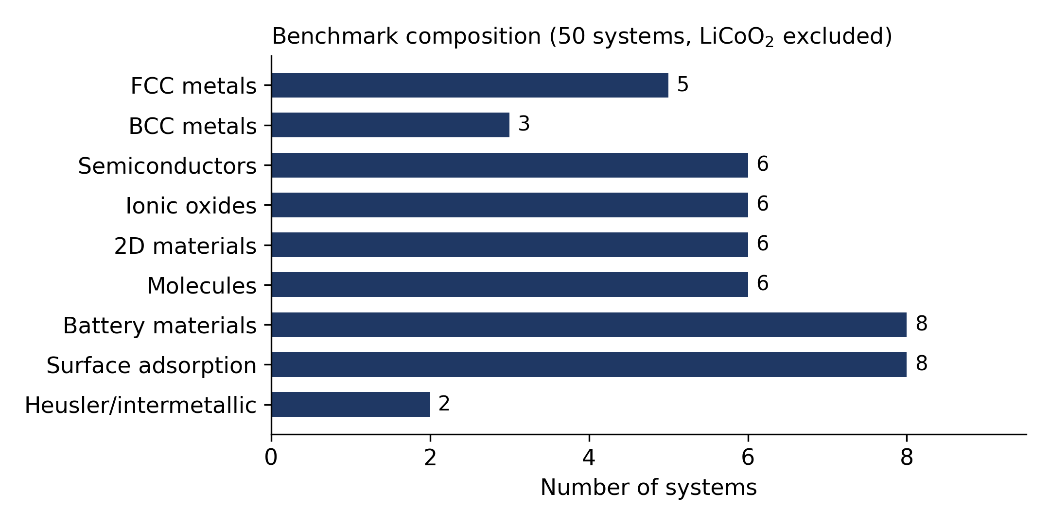
Figure 2. Composition of the 50-system benchmark by category.

2.6 Baselines and validation metrics
Two questions are kept separate. The first is whether the loop finds the right minimum. This is measured by comparing the active-learning minimum against a brute-force grid minimum, directly for three systems and through a projected baseline for the rest. The second is whether the loop is efficient. This is measured in two ways: the number of DFT calls, which does not depend on the machine, and the real wall-clock time of those calls, taken from the timing lines in the Quantum ESPRESSO output. The grid baseline uses 20 points for a one-variable search and 49 points, a 7 by 7 grid, for a two-variable search.

3 Results
The results are split into two layers. Layer one is about the optimizer: does it find the brute-force minimum, how much does it save, does the uncertainty help, and is the uncertainty meaningful. Layer two is a physical sanity check against literature structures. The main claim rests on layer one.

3.1 Benchmark coverage and convergence
All 50 systems produced a parsed report with a final result, a cache, and a recorded wall-clock time. Every run met the stopping rule. Most systems needed between 4 and 8 calls. The most expensive search by call count was CO on Ni(111), which needed 17. The median was 6 calls. Convergence against the pipeline's own stopping rule is a weak statement on its own, so the stronger checks follow in Sections 3.3 and 3.4.
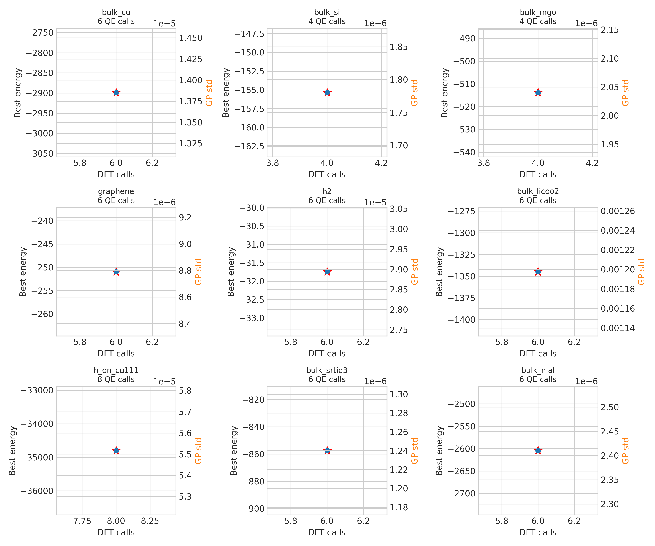
Figure 3. Convergence histories for representative systems, showing the computed points, the Gaussian-process mean with its uncertainty band, and the best energy found against the number of DFT calls.

3.2 Efficiency against the grid baseline
Across the 50 systems the loop used 311 DFT calls against 1174 for the grid, which is 73.5 percent fewer calls. In wall-clock terms the calls took 54 hours against a projected 183.6 hours for the grid, a saving of 129.6 hours, or 70.6 percent. The saving is not uniform. For one-variable searches the loop typically used 4 to 8 calls against 20, which is a 69.3 percent reduction in calls. For two-variable searches the reduction was larger, 86.1 percent, because the grid grows with the square of its resolution while the loop does not. The aggregate hours saved are also weighted toward a few expensive systems, so the median per-system saving is smaller than the total suggests. Both views are given here and in Appendix B so neither is read on its own.
Quantity | One-variable | Two-variable | All systems
Systems | 44 | 6 | 50
DFT calls, active learning | 270 | 41 | 311
DFT calls, grid baseline | 880 | 294 | 1174
Call reduction | 69.3% | 86.1% | 73.5%
Wall-time reduction | 63.5% | 86.2% | 70.6%
Wall-time saved (h) | 80.3 | 49.2 | 129.6
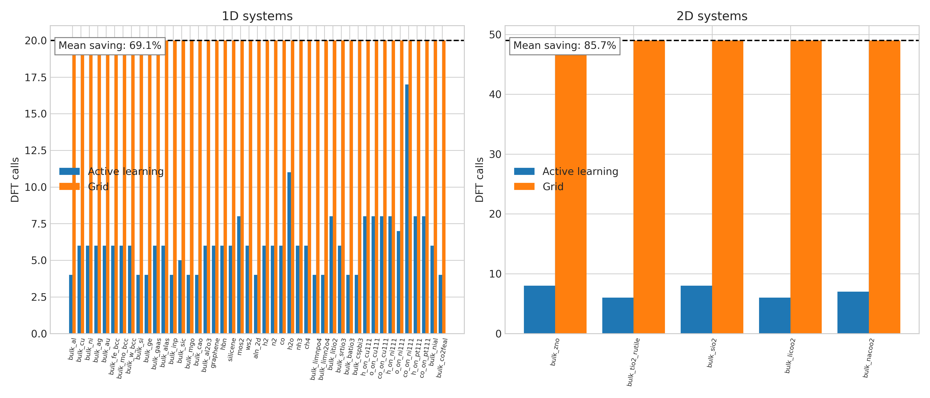
Figure 4. DFT calls used by the active-learning loop against the grid baseline for each system, separated into one- and two-variable searches.

3.3 Direct grid validation
To check that the loop finds the true minimum and not just a self-consistent one, three systems were run as full grids in Quantum ESPRESSO: Cu over 20 points, MoS2 over 49 points, and LiCoO2 over 49 points. In every case the active-learning minimum matched the grid minimum to better than 1 meV per atom. The Cu and MoS2 grids match their benchmark entries exactly. The LiCoO2 grid was computed under the earlier cutoff settings, before LiCoO2 was rerun for the benchmark at the higher 80 Ry cutoff with spin polarization, so it confirms optimizer correctness on a LiCoO2 landscape but does not correspond to the production benchmark energy. A matched-settings LiCoO2 grid scan is therefore on the list of planned checks. The roadmap for this project asks for 8 to 10 direct checks before submission. The remaining ones are listed in Appendix C; they require running Quantum ESPRESSO on the project machine and are not yet complete.
Validation system | Grid points | AL calls | Energy difference (eV/atom) | Result
Cu, FCC, 1D | 20 | 6 | 2.0e-4 | pass
MoS2, 2D | 49 | 8 | 9.2e-4 | pass
LiCoO2, 2D | 49 | 6 | 4.4e-9 | pass
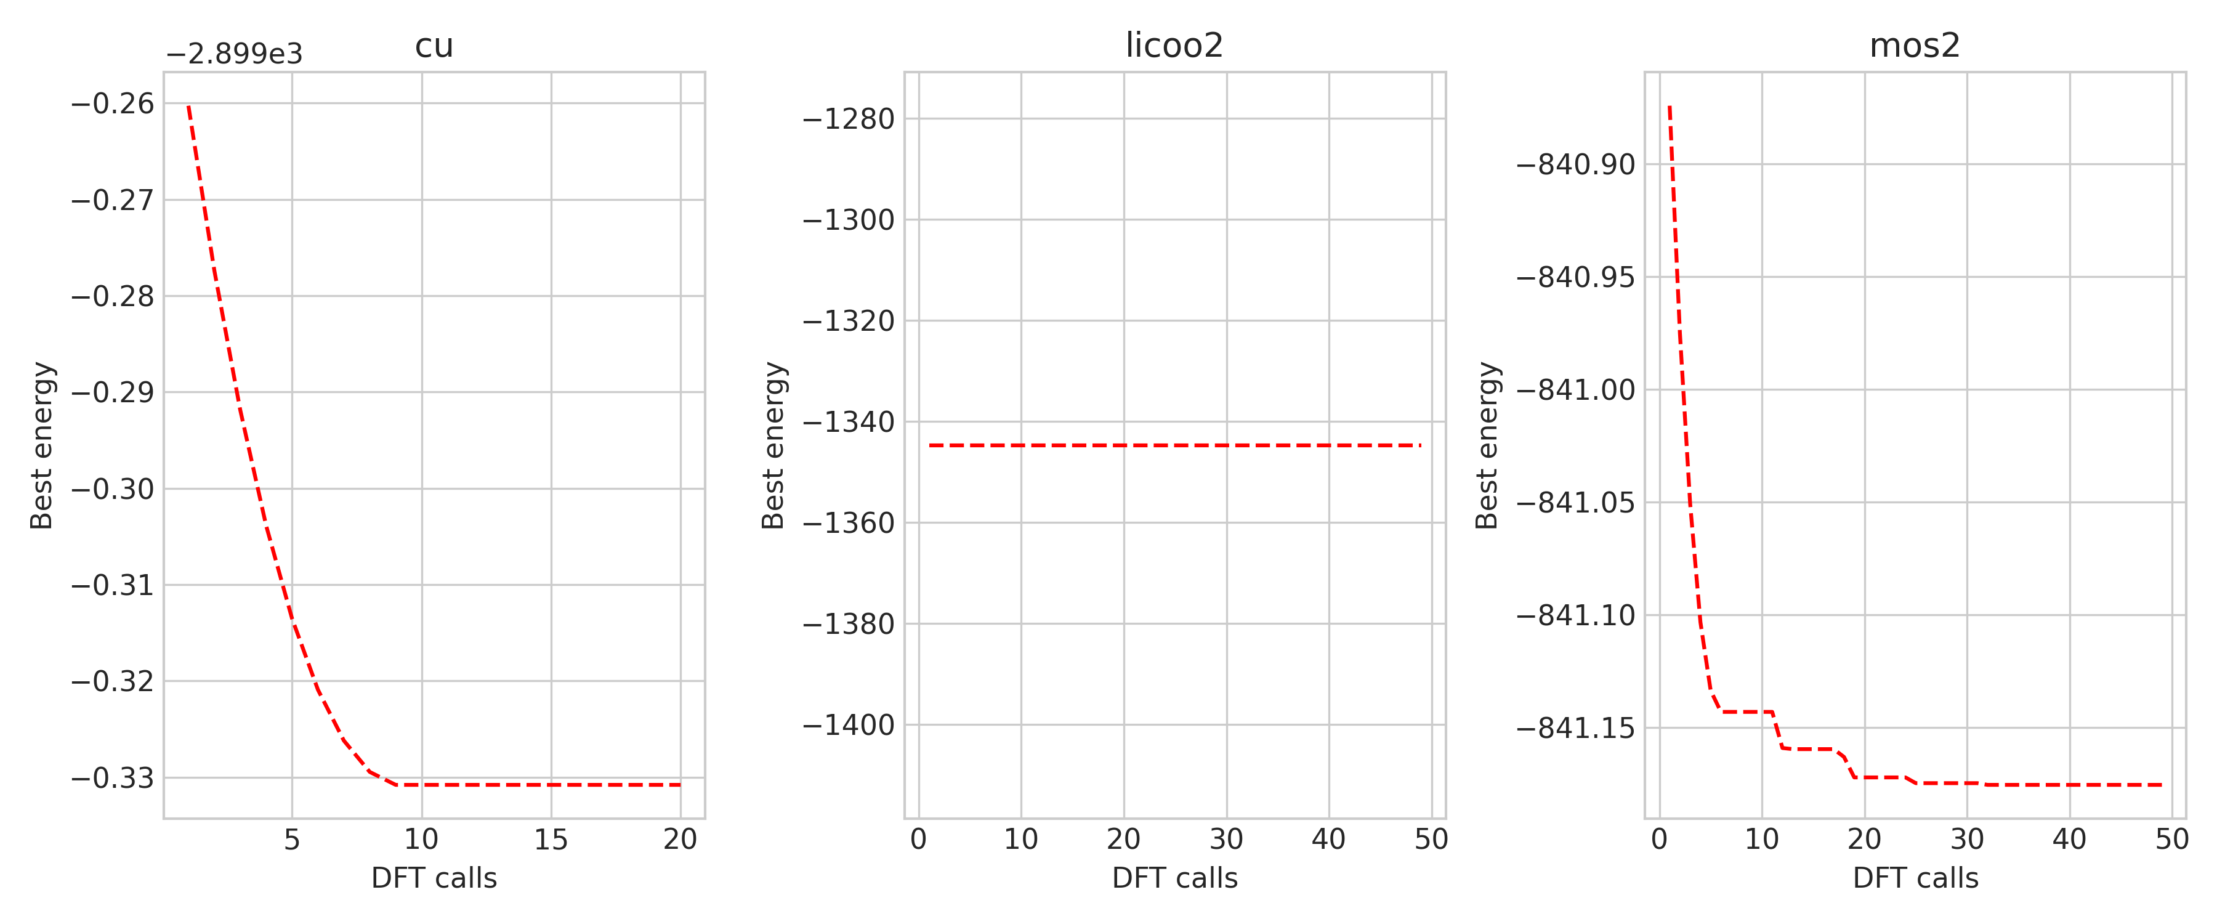
Figure 5. Fully computed grid landscapes with the active-learning minimum marked. The marked point sits at the grid minimum in each case.

3.4 Baseline and ablation comparison
Showing that the loop beats a grid does not by itself show that the surrogate is responsible. The next test holds the energy data fixed and changes only how points are chosen. Using the three fully computed grids, where the true energy at every point is known, four strategies were compared: the lower confidence bound used by ActiStruct, a version that uses only the Gaussian-process mean with no uncertainty term, uniform random sampling, and Latin hypercube sampling. Each strategy was given the same random seed points and run many times, and the number of calls needed to come within 1 meV per atom of the true minimum was recorded.
The result is clear and also honest about its limits. The two surrogate-based strategies reach the minimum far faster than random or Latin hypercube sampling, and the gap grows in two dimensions. On MoS2 the surrogate needs about 4 calls against 11 to 13 for the naive methods, and on LiCoO2 about 6 to 7 against 22 to 23. The lower confidence bound and the mean-only surrogate perform almost the same on these systems. On smooth, single-basin landscapes like these, the surrogate itself is what saves calls, and the uncertainty term in the acquisition adds little. The exploration term would be expected to matter more on rougher or multi-basin surfaces, which are outside this benchmark.
System | Grid | LCB (this work) | GP mean only | Random | Latin hypercube
Cu, 1D | 20 | 2 | 2 | 7 | 7
MoS2, 2D | 49 | 4 | 4.5 | 13 | 11
LiCoO2, 2D | 49 | 7 | 6 | 23 | 22
Values are the median number of calls, including seeds, to reach within 1 meV per atom of the true minimum, over many random initializations.
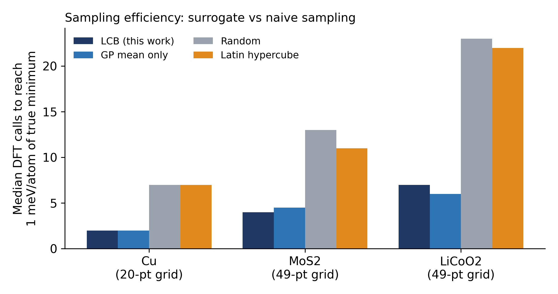
Figure 6. Median calls to reach the true minimum for each sampling strategy. The surrogate-based methods need far fewer calls than random or Latin hypercube sampling, with the largest gap on the two-variable systems.
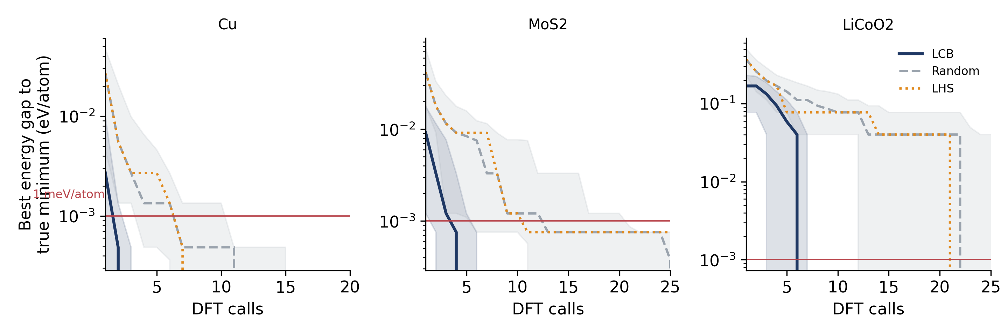
Figure 7. Best energy gap to the true minimum against number of calls for each strategy. The shaded bands are the interquartile range over random initializations. The red line marks 1 meV per atom.

3.5 Uncertainty behavior
A reviewer will ask whether the Gaussian-process uncertainty is meaningful or just printed. Two diagnostics were run on the three fully computed grids, where the true error is known at every point.
The first is calibration. For each nominal interval, such as a 90 percent interval, the fraction of true energies that actually fall inside was measured. The intervals are too narrow. Pooled over the three systems, the nominal 90 percent interval contains about 67 percent of points and the nominal 68 percent interval contains about 48 percent. In other words, the model is over-confident in absolute terms when it is trained on only a handful of points. The second diagnostic is ranking. The Spearman correlation between the predicted uncertainty and the true absolute error is positive across all three systems, from about 0.4 to 0.8. So even though the size of the error bar is not trustworthy, larger error bars do tend to mark larger errors.
The defensible statement is therefore the modest one. The uncertainty is a useful ranking signal for deciding where to sample, and it falls steadily as labels are added, but it should not be read as a calibrated confidence interval at these training-set sizes. Figure 9 shows the model uncertainty averaged over the search space dropping as points are added.
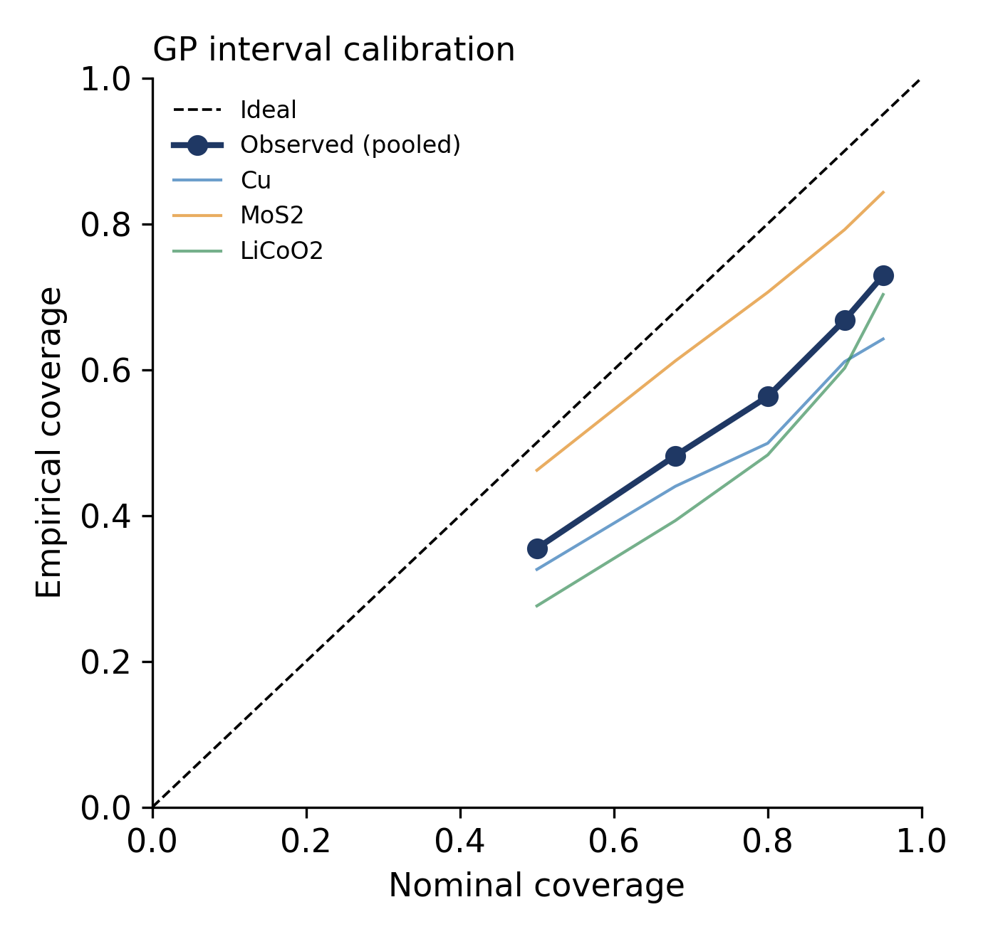
Figure 8. Calibration of the Gaussian-process intervals on the three fully computed grids. Points below the diagonal mean the intervals are too narrow.
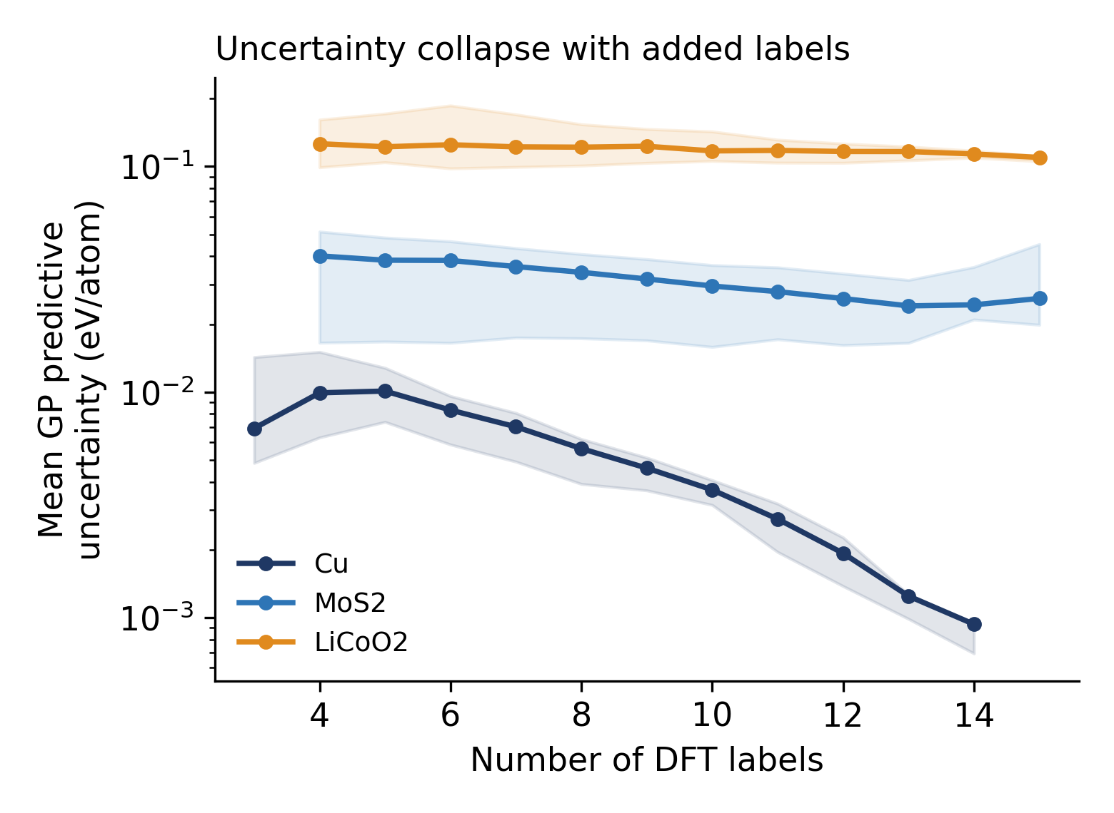
Figure 9. Mean predictive uncertainty over the search space as DFT labels are added, with interquartile bands over random initializations.

3.6 Structural sanity check
This section is the secondary, layer-two evidence. For the 34 systems with a published structural reference, the optimized primary parameter was compared against that reference. The mean absolute deviation is 0.64 percent and the worst case is 4.0 percent. This is within the spread seen between independent PBE codes, so it tells us the loop lands on the physically sensible minimum. It is not a claim that PBE itself is accurate, and it is not used to support the main result.
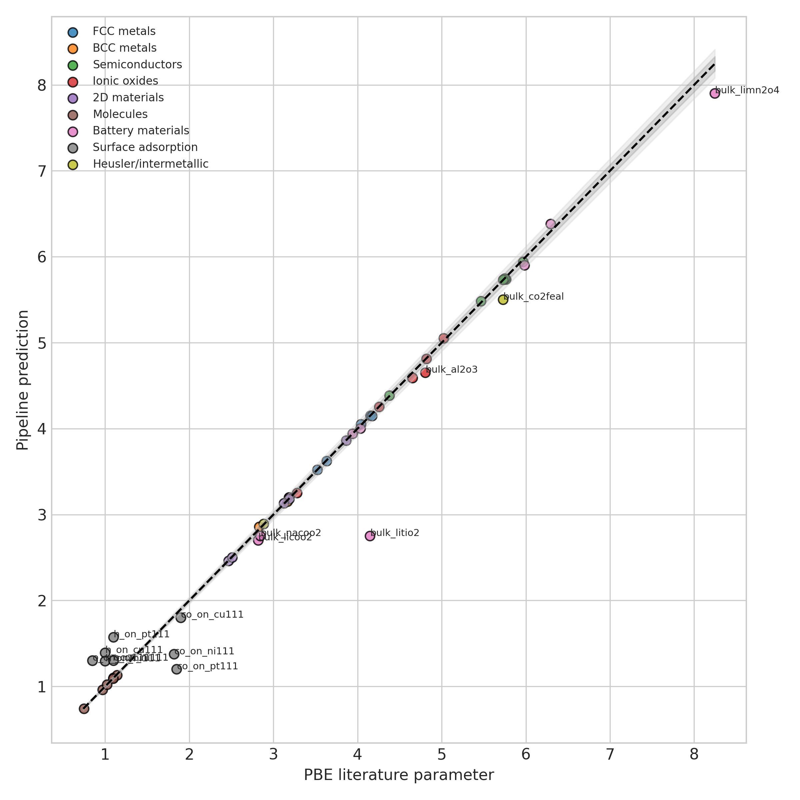
Figure 10. Optimized structural parameter against the reference value for the systems with a published reference. Points fall on the diagonal.
Surface-adsorption systems and several battery cells are left out of this comparison. They optimize an adsorption height or a simplified prototype cell rather than a full crystal structure, so a literature lattice constant is not the right reference. They are kept in the efficiency results, where they contribute the largest time savings, and are treated as stress tests of the loop rather than accuracy benchmarks.

3.6.1 Per-category summary
Category | N | Mean deviation | Calls, AL | Calls, grid | Call saving | Time saved (h)
FCC metals | 5 | 0.28% | 5.6 | 20.0 | - | 3.1
BCC metals | 3 | 0.58% | 6.0 | 20.0 | - | 2.3
Semiconductors | 6 | 0.24% | 4.8 | 20.0 | - | 3.4
Ionic oxides | 6 | 1.07% | 6.0 | 34.5 | - | 8.0
2D materials | 6 | 0.28% | 6.0 | 20.0 | - | 4.7
Molecules | 6 | 0.80% | 6.8 | 20.0 | - | 1.2
Heusler/intermetallic | 2 | 2.09% | 5.0 | 20.0 | - | 2.0
Battery materials | 8 | model | 5.4 | 27.3 | - | 64.4
Surface adsorption | 8 | model | 8.8 | 23.6 | - | 40.4
Rows marked model optimize an adsorption height or a prototype cell and are not compared against a literature structure. Mean deviation is the mean absolute percent deviation of the primary parameter.

4 Discussion

4.1 What the workflow does
The workflow takes a low-dimensional structure-optimization problem and solves it with far fewer DFT calls than a grid, without missing the minimum. The saving is real in both call count and wall-clock time, and it is largest for the two-variable searches and for the expensive systems where each call costs the most. The ablation shows the saving comes from the surrogate, not from luck in the sampling order.

4.2 What it does not do
The method does not improve the accuracy of the underlying DFT. It does not discover new materials, find reaction barriers, or predict thermochemistry. It is not a high-dimensional optimizer; the benchmark covers one and two variables only. It assumes a single-point total energy is a meaningful objective, which holds for lattice constants, bond lengths, layer parameters, and adsorption heights, but not for problems that need full relaxation or reference-state corrections. On smooth landscapes the uncertainty term in the acquisition adds little over a plain surrogate, as Section 3.4 shows.

4.3 Limitations to state in the manuscript
- For 47 of the 50 systems the grid baseline is projected from the measured cost per call, not run in full. Three systems were enumerated completely as a direct check. The projection should be described as a projection.
- The size of the saving depends on the grid density chosen for the baseline, 20 points in one variable and 49 in two. A coarser baseline would show a smaller saving. The chosen densities should be justified as the resolution needed to locate the minimum to comparable precision.
- Convergence in every system is measured against the pipeline's own stopping rule. The grid validation in Section 3.3 is the external check, and it currently covers three systems rather than the eight to ten the project roadmap targets.
- The Gaussian-process intervals are over-confident on sparse data. The uncertainty should be presented as a ranking signal, not as a calibrated interval.
- Known PBE issues apply to some systems and should be noted: the magnetic state of BCC Fe, spin and convergence on the Ni and Co surfaces, and the well-known overbinding of CO on Pt(111). Transition-metal oxides such as NaCoO2 and LiCoO2 can need DFT+U and careful spin treatment for quantitative energetics.

4.4 Extensions
The natural next steps are to add geometry relaxation inside each call, to compute proper adsorption and formation energies with reference states, and to move to higher-dimensional searches over composition or several structural variables at once. Each of these would also make the uncertainty term more important, since the landscapes would be rougher.

5 Conclusions
ActiStruct reaches the same DFT energy minimum as a full grid across a 50-system benchmark while using about 73 percent fewer Quantum ESPRESSO calls and about 71 percent less wall-clock time. On the systems with a published reference structure, the recovered parameter is within 0.64 percent on average. Three fully computed grids confirm the minimum to better than 1 meV per atom, and an ablation on those three shows the Gaussian-process surrogate is the source of the saving. The result is a method-and-software efficiency contribution with clearly stated limits, which is the right framing for both JCTC and JOSS.

Data and Code Availability
The analysis in this document is built from the per-system reports in outputs/reports, the parsed table all_results_clean.csv, the grid comparison and grid validation CSV files, and the Quantum ESPRESSO wall-times parsed from outputs/qe_runs. The ablation and calibration results come from the three fully computed grid files. The cleaned data tables generated for this report are all_results_clean.csv, excluded_or_stale_runs.csv, system_status_manifest.csv, and qe_settings_by_system.csv, in analysis/outputs/raw. Before submission the code should be placed in a public repository with a license, tests, and continuous integration, and archived to obtain a DOI, as set out in the project roadmap.

Appendix A Quantum ESPRESSO settings by system
All systems use PBE with the SSSP 1.3.0 PBE efficiency library, a convergence threshold of 1e-8 Ry, and a charge-density cutoff scaled to the wavefunction cutoff. The table lists the per-system values parsed from the run reports.
System | ecutwfc | kpts | smearing | degauss | spin
Al (FCC) | 50.0 | (12, 12, 12) | mv | 0.02 | False
Cu (FCC) | 70.0 | (12, 12, 12) | mv | 0.02 | False
Ni (FCC) | 60.0 | (12, 12, 12) | mv | 0.02 | False
Ag (FCC) | 60.0 | (12, 12, 12) | mv | 0.02 | False
Au (FCC) | 60.0 | (12, 12, 12) | mv | 0.02 | False
Fe (BCC) | 70.0 | (14, 14, 14) | mv | 0.02 | False
Mo (BCC) | 70.0 | (14, 14, 14) | mv | 0.02 | False
W (BCC) | 70.0 | (14, 14, 14) | mv | 0.02 | False
Si (diamond) | 50.0 | (8, 8, 8) | gaussian | 0.01 | False
Ge (diamond) | 50.0 | (8, 8, 8) | gaussian | 0.01 | False
GaAs | 60.0 | (8, 8, 8) | gaussian | 0.01 | False
AlAs | 60.0 | (8, 8, 8) | gaussian | 0.01 | False
InP | 60.0 | (8, 8, 8) | gaussian | 0.01 | False
SiC | 60.0 | (8, 8, 8) | gaussian | 0.01 | False
MgO | 70.0 | (8, 8, 8) | gaussian | 0.01 | False
CaO | 70.0 | (8, 8, 8) | gaussian | 0.01 | False
ZnO | 70.0 | (8, 8, 6) | gaussian | 0.01 | False
TiO2 rutile | 70.0 | (8, 8, 10) | gaussian | 0.01 | False
Al2O3 | 70.0 | (6, 6, 4) | gaussian | 0.01 | False
SiO2 alpha-quartz | 70.0 | (6, 6, 6) | gaussian | 0.01 | False
Graphene | 50.0 | (8, 8, 1) | gaussian | 0.02 | False
h-BN | 60.0 | (8, 8, 1) | gaussian | 0.01 | False
Silicene | 50.0 | (6, 6, 1) | gaussian | 0.01 | False
MoS2 | 70.0 | (6, 6, 1) | gaussian | 0.01 | False
WS2 | 70.0 | (6, 6, 1) | gaussian | 0.01 | False
2D AlN | 60.0 | (8, 8, 1) | gaussian | 0.01 | False
H2 | 50.0 | (1, 1, 1) | gaussian | 0.01 | False
N2 | 60.0 | (1, 1, 1) | gaussian | 0.01 | False
CO | 60.0 | (1, 1, 1) | gaussian | 0.01 | False
H2O | 60.0 | (1, 1, 1) | gaussian | 0.01 | False
NH3 | 60.0 | (1, 1, 1) | gaussian | 0.01 | False
CH4 | 60.0 | (1, 1, 1) | gaussian | 0.01 | False
NaCoO2 | 80.0 | (6, 6, 2) | mv | 0.02 | True
LiMnPO4 | 50.0 | (2, 2, 2) | gaussian | 0.03 | False
LiMn2O4 | 70.0 | (4, 4, 4) | mv | 0.02 | False
LiTiO2 | 80.0 | (6, 6, 3) | gaussian | 0.01 | False
SrTiO3 | 70.0 | (6, 6, 6) | gaussian | 0.01 | False
BaTiO3 | 70.0 | (6, 6, 6) | gaussian | 0.01 | False
CsPbI3 | 70.0 | (4, 4, 4) | gaussian | 0.01 | False
H/Cu(111) | 80.0 | (6, 6, 1) | mv | 0.015 | False
O/Cu(111) | 80.0 | (6, 6, 1) | mv | 0.015 | False
CO/Cu(111) | 80.0 | (6, 6, 1) | mv | 0.015 | False
H/Ni(111) | 70.0 | (4, 4, 1) | mv | 0.02 | False
O/Ni(111) | 70.0 | (4, 4, 1) | mv | 0.02 | False
CO/Ni(111) | 70.0 | (4, 4, 1) | mv | 0.02 | False
H/Pt(111) | 80.0 | (6, 6, 1) | mv | 0.015 | False
CO/Pt(111) | 70.0 | (4, 4, 1) | mv | 0.02 | False
NiAl | 70.0 | (10, 10, 10) | mv | 0.02 | False
Co2FeAl | 70.0 | (8, 8, 8) | mv | 0.02 | False
Layered LiCoO2 | 80.0 | (6, 6, 2) | mv | 0.02 | True

Appendix B Per-system efficiency
System | Dim | AL calls | Grid calls | s/call | AL (h) | Grid (h) | Saved (h) | Save %
2D AlN | 1 | 4 | 20 | 122 | 0.14 | 0.68 | 0.54 | 80%
Graphene | 1 | 6 | 20 | 40 | 0.07 | 0.22 | 0.16 | 70%
h-BN | 1 | 6 | 20 | 100 | 0.17 | 0.55 | 0.39 | 70%
MoS2 | 1 | 8 | 20 | 504 | 1.12 | 2.80 | 1.68 | 60%
Silicene | 1 | 6 | 20 | 103 | 0.17 | 0.57 | 0.40 | 70%
WS2 | 1 | 6 | 20 | 407 | 0.68 | 2.26 | 1.58 | 70%
BaTiO3 | 1 | 4 | 20 | 37 | 0.04 | 0.21 | 0.16 | 80%
CsPbI3 | 1 | 4 | 20 | 72 | 0.08 | 0.40 | 0.32 | 80%
LiMn2O4 | 1 | 4 | 20 | 5850 | 6.50 | 32.50 | 26.00 | 80%
LiMnPO4 | 1 | 4 | 20 | 162 | 0.18 | 0.90 | 0.72 | 80%
LiTiO2 | 1 | 8 | 20 | 358 | 0.79 | 1.99 | 1.19 | 60%
SrTiO3 | 1 | 6 | 20 | 61 | 0.10 | 0.34 | 0.24 | 70%
Fe (BCC) | 1 | 6 | 20 | 340 | 0.57 | 1.89 | 1.32 | 70%
Mo (BCC) | 1 | 6 | 20 | 139 | 0.23 | 0.77 | 0.54 | 70%
W (BCC) | 1 | 6 | 20 | 101 | 0.17 | 0.56 | 0.39 | 70%
Ag (FCC) | 1 | 6 | 20 | 165 | 0.28 | 0.92 | 0.64 | 70%
Al (FCC) | 1 | 4 | 20 | 9 | 0.01 | 0.05 | 0.04 | 80%
Au (FCC) | 1 | 6 | 20 | 178 | 0.30 | 0.99 | 0.69 | 70%
Cu (FCC) | 1 | 6 | 20 | 74 | 0.12 | 0.41 | 0.29 | 70%
Ni (FCC) | 1 | 6 | 20 | 362 | 0.60 | 2.01 | 1.41 | 70%
Co2FeAl | 1 | 4 | 20 | 370 | 0.41 | 2.05 | 1.64 | 80%
NiAl | 1 | 6 | 20 | 90 | 0.15 | 0.50 | 0.35 | 70%
Al2O3 | 1 | 6 | 20 | 297 | 0.50 | 1.65 | 1.16 | 70%
CaO | 1 | 4 | 20 | 79 | 0.09 | 0.44 | 0.35 | 80%
MgO | 1 | 4 | 20 | 31 | 0.03 | 0.17 | 0.14 | 80%
CH4 | 1 | 6 | 20 | 65 | 0.11 | 0.36 | 0.25 | 70%
CO | 1 | 6 | 20 | 69 | 0.12 | 0.38 | 0.27 | 70%
H2 | 1 | 6 | 20 | 21 | 0.03 | 0.12 | 0.08 | 70%
H2O | 1 | 11 | 20 | 54 | 0.16 | 0.30 | 0.13 | 45%
N2 | 1 | 6 | 20 | 51 | 0.09 | 0.28 | 0.20 | 70%
NH3 | 1 | 6 | 20 | 70 | 0.12 | 0.39 | 0.27 | 70%
AlAs | 1 | 6 | 20 | 135 | 0.22 | 0.75 | 0.52 | 70%
GaAs | 1 | 6 | 20 | 391 | 0.65 | 2.17 | 1.52 | 70%
Ge (diamond) | 1 | 4 | 20 | 92 | 0.10 | 0.51 | 0.41 | 80%
InP | 1 | 4 | 20 | 147 | 0.16 | 0.82 | 0.65 | 80%
Si (diamond) | 1 | 4 | 20 | 40 | 0.04 | 0.22 | 0.18 | 80%
SiC | 1 | 5 | 20 | 30 | 0.04 | 0.17 | 0.12 | 75%
CO/Ni(111) | 1 | 17 | 20 | 2457 | 11.60 | 13.65 | 2.05 | 15%
CO/Pt(111) | 1 | 8 | 20 | 1551 | 3.45 | 8.62 | 5.17 | 60%
H/Cu(111) | 1 | 8 | 20 | 573 | 1.27 | 3.18 | 1.91 | 60%
H/Ni(111) | 1 | 8 | 20 | 1404 | 3.12 | 7.80 | 4.68 | 60%
H/Pt(111) | 1 | 8 | 20 | 1244 | 2.76 | 6.91 | 4.15 | 60%
O/Cu(111) | 1 | 8 | 20 | 637 | 1.42 | 3.54 | 2.12 | 60%
O/Ni(111) | 1 | 7 | 20 | 3687 | 7.17 | 20.48 | 13.31 | 65%
Layered LiCoO2 | 2 | 6 | 49 | 841 | 1.40 | 11.45 | 10.04 | 88%
NaCoO2 | 2 | 7 | 49 | 2209 | 4.30 | 30.07 | 25.77 | 86%
SiO2 alpha-quartz | 2 | 8 | 49 | 418 | 0.93 | 5.68 | 4.76 | 84%
TiO2 rutile | 2 | 6 | 49 | 72 | 0.12 | 0.98 | 0.86 | 88%
ZnO | 2 | 8 | 49 | 62 | 0.14 | 0.85 | 0.71 | 84%
CO/Cu(111) | 2 | 6 | 49 | 591 | 0.98 | 8.04 | 7.06 | 88%

Appendix C Data integrity

C.1 Excluded and stale runs
System | Reason | Action
LiFePO4 | Replaced by LiMnPO4 in the 50-system benchmark after three convergence failures; not part of the clean benchmark set. | exclude
NASICON Li2NaV2(PO4)3 | Run status unconfirmed; no parsed FINAL RESULT in clean set. | exclude pending verification

C.2 Planned direct grid validations
Three systems are validated against a full grid in Section 3.3. The project roadmap targets eight to ten. The following systems are proposed to complete the set, chosen to cover a spin-polarized metal, a semiconductor, an ionic oxide, and several expensive systems where the time saving is largest. These require running Quantum ESPRESSO on the project machine.
System | Why it is included
LiCoO2 (matched settings) | production entry was rerun at 80 Ry with spin polarization, so a grid at those settings is needed
Fe BCC | spin-polarized metal, tests magnetic robustness
Si diamond | semiconductor baseline
MgO rocksalt | ionic oxide
H2O | molecule with an internal coordinate
NaCoO2 | transition-metal oxide, large time saving
LiMn2O4 | expensive battery cell, largest single time saving
O on Ni(111) | expensive surface, strong time-saving case
CO on Pt(111) | expensive surface, known PBE difficulty

C.3 System status
All 50 benchmark systems have a script, settings, a report, a cache, a parsed result, and a recorded wall-time. The manifest below is abbreviated; the full version is system_status_manifest.csv.
System | Category | Report | Wall-time | QE calls | Converged
Al (FCC) | FCC metals | yes | yes | 4 | True
Cu (FCC) | FCC metals | yes | yes | 6 | True
Ni (FCC) | FCC metals | yes | yes | 6 | True
Ag (FCC) | FCC metals | yes | yes | 6 | True
Au (FCC) | FCC metals | yes | yes | 6 | True
Fe (BCC) | BCC metals | yes | yes | 6 | True
Mo (BCC) | BCC metals | yes | yes | 6 | True
W (BCC) | BCC metals | yes | yes | 6 | True
Si (diamond) | Semiconductors | yes | yes | 4 | True
Ge (diamond) | Semiconductors | yes | yes | 4 | True
GaAs | Semiconductors | yes | yes | 6 | True
AlAs | Semiconductors | yes | yes | 6 | True
InP | Semiconductors | yes | yes | 4 | True
SiC | Semiconductors | yes | yes | 5 | True
MgO | Ionic oxides | yes | yes | 4 | True
CaO | Ionic oxides | yes | yes | 4 | True
ZnO | Ionic oxides | yes | yes | 8 | True
TiO2 rutile | Ionic oxides | yes | yes | 6 | True
Al2O3 | Ionic oxides | yes | yes | 6 | True
SiO2 alpha-quartz | Ionic oxides | yes | yes | 8 | True
Graphene | 2D materials | yes | yes | 6 | True
h-BN | 2D materials | yes | yes | 6 | True
Silicene | 2D materials | yes | yes | 6 | True
MoS2 | 2D materials | yes | yes | 8 | True
WS2 | 2D materials | yes | yes | 6 | True
2D AlN | 2D materials | yes | yes | 4 | True
H2 | Molecules | yes | yes | 6 | True
N2 | Molecules | yes | yes | 6 | True
CO | Molecules | yes | yes | 6 | True
H2O | Molecules | yes | yes | 11 | True
NH3 | Molecules | yes | yes | 6 | True
CH4 | Molecules | yes | yes | 6 | True
NaCoO2 | Battery materials | yes | yes | 7 | True
LiMnPO4 | Battery materials | yes | yes | 4 | True
LiMn2O4 | Battery materials | yes | yes | 4 | True
LiTiO2 | Battery materials | yes | yes | 8 | True
SrTiO3 | Battery materials | yes | yes | 6 | True
BaTiO3 | Battery materials | yes | yes | 4 | True
CsPbI3 | Battery materials | yes | yes | 4 | True
H/Cu(111) | Surface adsorption | yes | yes | 8 | True
O/Cu(111) | Surface adsorption | yes | yes | 8 | True
CO/Cu(111) | Surface adsorption | yes | yes | 8 | True
H/Ni(111) | Surface adsorption | yes | yes | 8 | True
O/Ni(111) | Surface adsorption | yes | yes | 7 | True
CO/Ni(111) | Surface adsorption | yes | yes | 17 | True
H/Pt(111) | Surface adsorption | yes | yes | 8 | True
CO/Pt(111) | Surface adsorption | yes | yes | 8 | True
NiAl | Heusler/intermetallic | yes | yes | 6 | True
Co2FeAl | Heusler/intermetallic | yes | yes | 4 | True
Layered LiCoO2 | Battery materials | yes | yes | 6 | True

Appendix D Reference provenance
Reference values used in the structural sanity check, with their source. PBE lattice constants for the elemental metals, semiconductors, and simple oxides follow the benchmark of Haas, Tran, and Blaha. Molecular bond lengths are experimental. Values for two-dimensional materials and the intermetallic should have a per-material identifier attached before submission, since they are drawn from scattered primary literature. None of these values is used to support the main efficiency claim.
System | Quantity | Reference | Type | Source | Note
Al (FCC) | a (Å) | 4.042 | PBE-DFT | Haas, Tran, Blaha, Phys. Rev. B 79, 085104 (2009) | structural sanity check
Cu (FCC) | a (Å) | 3.634 | PBE-DFT | Haas, Tran, Blaha, Phys. Rev. B 79, 085104 (2009) | structural sanity check
Ni (FCC) | a (Å) | 3.524 | PBE-DFT | Haas, Tran, Blaha, Phys. Rev. B 79, 085104 (2009) | structural sanity check
Ag (FCC) | a (Å) | 4.154 | PBE-DFT | Haas, Tran, Blaha, Phys. Rev. B 79, 085104 (2009) | structural sanity check
Au (FCC) | a (Å) | 4.174 | PBE-DFT | Haas, Tran, Blaha, Phys. Rev. B 79, 085104 (2009) | structural sanity check
Fe (BCC) | a (Å) | 2.832 | PBE-DFT | Haas, Tran, Blaha, Phys. Rev. B 79, 085104 (2009) | structural sanity check
Mo (BCC) | a (Å) | 3.168 | PBE-DFT | Haas, Tran, Blaha, Phys. Rev. B 79, 085104 (2009) | structural sanity check
W (BCC) | a (Å) | 3.185 | PBE-DFT | Haas, Tran, Blaha, Phys. Rev. B 79, 085104 (2009) | structural sanity check
Si (diamond) | a (Å) | 5.468 | PBE-DFT | Haas, Tran, Blaha, Phys. Rev. B 79, 085104 (2009) | structural sanity check
Ge (diamond) | a (Å) | 5.766 | PBE-DFT | Haas, Tran, Blaha, Phys. Rev. B 79, 085104 (2009) | structural sanity check
GaAs | a (Å) | 5.75 | PBE-DFT | Haas, Tran, Blaha, Phys. Rev. B 79, 085104 (2009) | structural sanity check
AlAs | a (Å) | 5.731 | PBE-DFT | Haas, Tran, Blaha, Phys. Rev. B 79, 085104 (2009) | structural sanity check
InP | a (Å) | 5.969 | PBE-DFT | Haas, Tran, Blaha, Phys. Rev. B 79, 085104 (2009) | structural sanity check
SiC | a (Å) | 4.38 | PBE-DFT | Haas, Tran, Blaha, Phys. Rev. B 79, 085104 (2009) | structural sanity check
MgO | a (Å) | 4.258 | PBE-DFT | Haas, Tran, Blaha, Phys. Rev. B 79, 085104 (2009) | structural sanity check
CaO | a (Å) | 4.82 | PBE-DFT | Haas, Tran, Blaha, Phys. Rev. B 79, 085104 (2009) | structural sanity check
ZnO | a (Å) | 3.282 | PBE-DFT | Haas, Tran, Blaha, Phys. Rev. B 79, 085104 (2009) | structural sanity check
TiO2 rutile | a (Å) | 4.653 | PBE-DFT | Haas, Tran, Blaha, Phys. Rev. B 79, 085104 (2009) | structural sanity check
Al2O3 | a (Å) | 4.806 | PBE-DFT | Haas, Tran, Blaha, Phys. Rev. B 79, 085104 (2009) | structural sanity check
SiO2 alpha-quartz | a (Å) | 5.025 | PBE-DFT | Haas, Tran, Blaha, Phys. Rev. B 79, 085104 (2009) | structural sanity check
Graphene | a (Å) | 2.468 | PBE-DFT | Primary DFT literature (per material) | attach per-material DOI / Materials Project ID before submission
h-BN | a (Å) | 2.512 | PBE-DFT | Primary DFT literature (per material) | attach per-material DOI / Materials Project ID before submission
Silicene | a (Å) | 3.866 | PBE-DFT | Primary DFT literature (per material) | attach per-material DOI / Materials Project ID before submission
MoS2 | a (Å) | 3.19 | PBE-DFT | Primary DFT literature (per material) | attach per-material DOI / Materials Project ID before submission
WS2 | a (Å) | 3.19 | PBE-DFT | Primary DFT literature (per material) | attach per-material DOI / Materials Project ID before submission
2D AlN | a (Å) | 3.126 | PBE-DFT | Primary DFT literature (per material) | attach per-material DOI / Materials Project ID before submission
H2 | bond (Å) | 0.75 | Experimental | NIST CCCBDB; Huber & Herzberg, Molecular Spectra (1979) | structural sanity check
N2 | bond (Å) | 1.101 | Experimental | NIST CCCBDB; Huber & Herzberg, Molecular Spectra (1979) | structural sanity check
CO | bond (Å) | 1.144 | Experimental | NIST CCCBDB; Huber & Herzberg, Molecular Spectra (1979) | structural sanity check
H2O | bond (Å) | 0.971 | Experimental | NIST CCCBDB; Huber & Herzberg, Molecular Spectra (1979) | structural sanity check
NH3 | bond (Å) | 1.024 | Experimental | NIST CCCBDB; Huber & Herzberg, Molecular Spectra (1979) | structural sanity check
CH4 | bond (Å) | 1.097 | Experimental | NIST CCCBDB; Huber & Herzberg, Molecular Spectra (1979) | structural sanity check
NiAl | a (Å) | 2.885 | PBE-DFT | PBE lattice-constant literature (per compound) | attach per-material DOI / Materials Project ID before submission
Co2FeAl | a (Å) | 5.73 | PBE-DFT | PBE lattice-constant literature (per compound) | attach per-material DOI / Materials Project ID before submission

Selected references
- Todorovic, Gutmann, Corander, Rinke. Bayesian inference of atomistic structure in functional materials. npj Comput. Mater. 5, 35 (2019).
- Giannozzi et al. Advanced capabilities for materials modelling with Quantum ESPRESSO. J. Phys.: Condens. Matter 29, 465901 (2017).
- Lejaeghere et al. Reproducibility in density functional theory calculations of solids. Science 351, aad3000 (2016).
- Haas, Tran, Blaha. Calculation of the lattice constant of solids with semilocal functionals. Phys. Rev. B 79, 085104 (2009).
- Shahriari, Swersky, Wang, Adams, de Freitas. Taking the human out of the loop: a review of Bayesian optimization. Proc. IEEE 104, 148 (2016).

